Module – 1_ Fundamentals

Komal shah

1. **What is SDLC?**

Sdlc: - Software development lifecycle

*Sdlc is a process how to develop, maintain, replaces and enhances specific software step by step with good quality, in budget and on time.*

*In simple word “entire life time of software from beginning to ending”*

***SDLC phases***

**2) What is software testing?**

Software testing it’s mean to check software is done with Complete according to customer requirement and also check software quality.

A software process based on well defined software quality control and testing standards, testing methods, strategy, test criteria and tools.

Type of testing

1. Software testing
2. Manual testing

**3) What is agile methodology?**

Software engineer do work according to customer requirement, quick delivery and adapting to change any time rather than following the step by step method.

Software provides to customer on every step for check if they want change in any feature because in this methodology customer satisfaction is most important part.

**4) What is SRS?**

What requirement we need for developing the software that called software requirement specification.

Types of requirement

Customer requirements

Functional requirements

Non-functional requirements

**5) What is oops?**

Oops (object oriented programming system)

Object oriented programming system is collation of object.

Like if object is face book application than oops is

Create story

Massage feature

f

Profile uploading part

Video market place

Like this all feature is hidden from outside.

**6) Write Basic Concepts of oops**

Class: - Collection of object.

Object: - Collection of class.

Encapsulation: - Hidden part of the class together we can call encapsulation.

Abstraction: - Process of hiding the implementation details and showing only functionality to the user.

Polymorphism: - When one task performed by different ways is known as polymorphism.

Inheritance: - When one class take the property of another class.

**7) What is object?**

Any entity has state and behaviour is known as object an object part of the class.

Each object has identity, behaviour and state.

One part of the class like what’s app application is class than status part in what’s app is object.

**8) What is class?**

Class is a collection of data member and faction.

Class is a blueprint to define the properties and behaviour of object.

In the class logical template to create objects that share common properties and method.

What’s app is collection of future like status, massages, group, profile upload.

**9) What is encapsulation?**

Encapsulation is process of cover code and data together in a single unit.

Ex. Capsule which is mix of so many medicines.

We can create a fully encapsulated class by making all data members of the class private.

If filed declared private it cannot be accessed by anyone outside the class thereby hiding the fields within the class.

**10) What is inheritance?**

When one class take the property of another class.

Inheritance is a way of representing real-world relationships between the two. Like bike, car, cycle that’s inheritance of vehicle.

**11) What is polymorphism?**

When one task performed by different ways is known as polymorphism.

Polymorphism means more than one forms.

Polymorphism is the ability of a variable, object, or function to take on multiple forms.

**12) Draw Use case on online book shopping**

**Online book shopping use case**

Actor

**13) Draw Use case on online bill payment system (paytm)**

Actor

**Online bill payment system (paytm)**

**14) Write SDLC phases with basic introduction.**

Requirement gathering

In requirement phases know about the customer needs in natural language and after that supply by diagram and table.

Functional requirement

Non-functional requirement

Analysis

In these phase considering requirement, first idea how to convert in new system for prototype.

In this phase all documentary delivered by the requirement phase and maps the requirements in to architecture.

Design

In this phase create a design according to delivered documents its help to clarify the objectives and goals of the project.

In these phase also include create prototype, select and finalize, product analysis and improve.

Implementation

In this phase put the project plan into the action according to architecture document from analysis phase and the design documents from design phase.

And also deal with issue of the quality, performance and debugging.

Testing

Testing is process of executing a program or part of program with the intention of finding errors for better quality and customer satisfaction.

Maintenance

Maintenance is the process of changing, modifying, and updating software to keep up with customer needs.

Corrective maintenance

Preventive maintenance

Risk-based maintenance

Condition-based maintenance

**15) Explain Phases of the waterfall model**

Waterfall

There are step to complete software making system like

In this process you need to do work Step by step you can’t go back if you find any type of problem In softer you have to forward this process with mistake.

When to use

Customer requirements are clear with their requirement.

Project is short.

All employment is stable and trained.

Customer required proper documents.

Why you need to use

Easy to arrange a task

Short and well manage on each and every step.

All the process completed on in one time.

Project will do in short term.

Simple to understand and use.

Why not use

Not work for long term project.

High risk because if staff pass the project with bugs that’s huge effect on quality.

Dose not gives any feedback part.

Dose not allows go back.

It is very difficult to go back after you finish process.

**16) Write phases of spiral model**

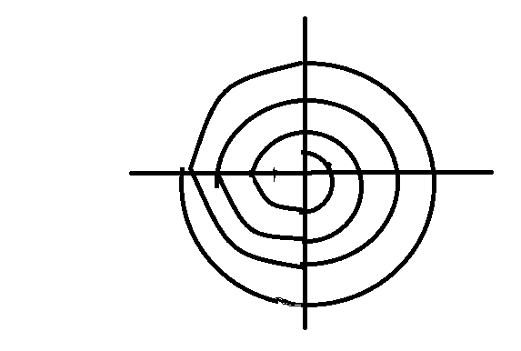

1. Planning (information gathering)

2. Risk Analysis (prototype, design)

3. Coding (testing)

4. Project evaluation

1 .Planning (information gathering)

Identify and understanding customer requirement, performing risk analysis, building the prototype and evaluation of the software’s performance.

2. Risk Analysis (prototype, design)

In this phase make a design, prototype according to planning phase and identify future events that may adversely impact a company.

3. Coding (testing)

In this phase put the project plan into the action according to architecture document from planning phase and the design documents from risk analysis.

4. Project evaluation

This phase allows the customer to evaluate the output of project to date before the project continues to the next spiral.

**17) Write agile manifesto principles.**

1) Priority is satisfying the customer by time to time delivery of software.

2) Always available for change requirements even if your project on last stage.

3) Deliver working software in part so they can understand if they want to change.

4) Business people and developer work together daily throughout the project because of time shortage.

5) Do support each other and free environment and trust to get job done.

6) Its most effective method if you face-to-face conversation so you can solve problem on same time.

7) Working software is primary process.

8) Agile process promotes sustainable development. Development speed constant so you can stable on same quality.

9) Continuous attention to great design enhances agility.

10) Simplicity the art of maximizing the amount of work is not done.

11) All work on same project on one time so you can easily know what work is not done.

**18) Explain working methodology of agile model and also write pros and cons.**

Agile model

Software engineer do work according to customer requirement, quick Delivery and adapting to change any time rather than following to set plan.

Pros

1) Customer satisfaction because of changing according their requirement and delivery on time.

2) Strong and on time communication between engineer and developer because all work together.

3) Any time changes acceptable even on last stage.

4) Little planning required.

5) Update version saw customer between the development process.

Cons

1) Not suitable for long term project.

2) Not work when customer change requirement again and again and customer is not sure.

3) Less paper work.

4) When customer need to change on last stage it’s create the problem.

**19) Draw use case on Online shopping product using COD**

**Online shopping product (cod)**

Actor

**20) Draw use case on Online shopping product using payment gateway**

**Actor**

**Online shopping product by payment gate way**